**UY2 Connector：**

**Using E-9Y to crimp UY2 and confirming the gel inside is squeezed out of the butt inserted with two 0.4mm wires**

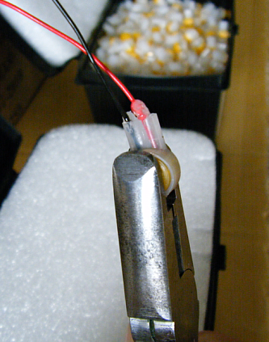

**Confirming UY2 is passed by the continuity test.**

