UY2 Connector：
Using E-9Y to crimp UY2 and confirming the gel inside is squeezed out of the butt inserted with two 0.4mm wires
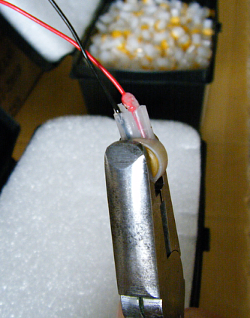

Confirming UY2 is passed by the continuity test.
